I – Menus

The Canvas
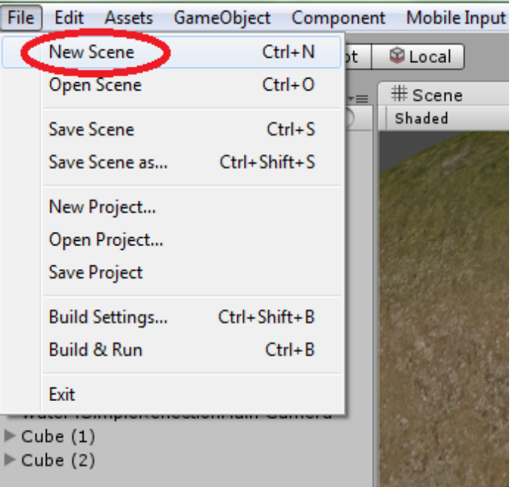
Begin by creating a new scene by clicking “File” and “New Scene”.

Save it as “mainMenu”.

Switch to 2D mode.
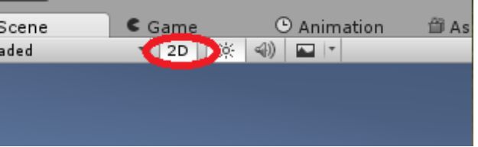

Now go to “GameObject”, “UI”, and “Canvas”.

Double-click on the new “Canvas” object to centre the camera onto it. The white box is your canvas. This box will be filling up the player's screen.

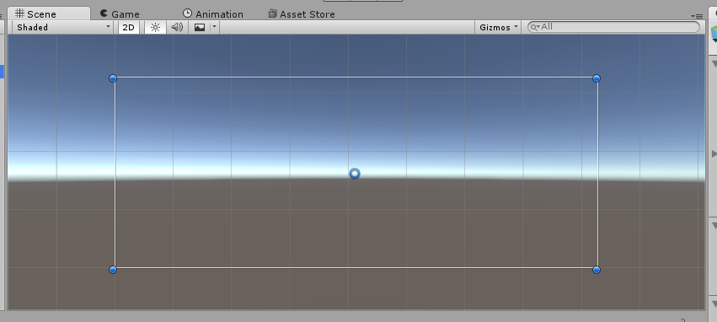

The Background
Go to “GameObject”, “UI”, and “Image”. A white square will appear inside your canvas and should automatically be parented to it. This is an image object. Where are going to apply a sprite to it, kind of like when you apply a material to a standard cube object.

Click and drag the blue dots to fit the image to the canvas.
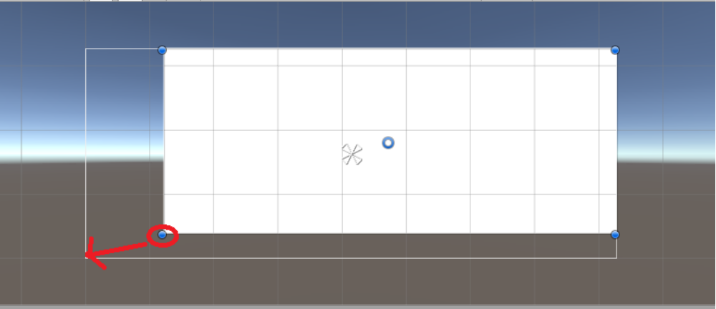
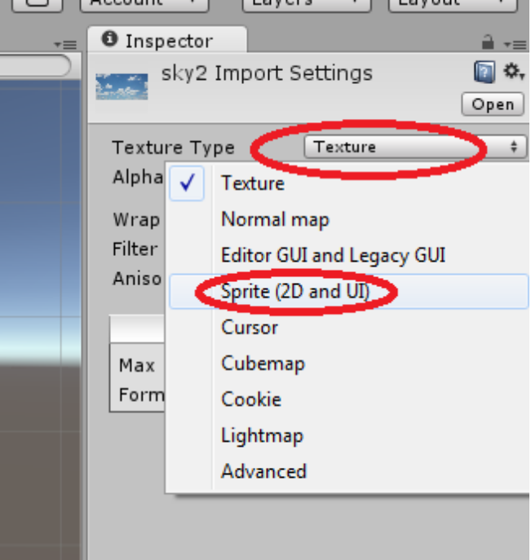
Now create or find an image that you would like to use as a background and save it to your Assets folder. Your image will be a texture by default so you will need to change it to a sprite in the inspector.

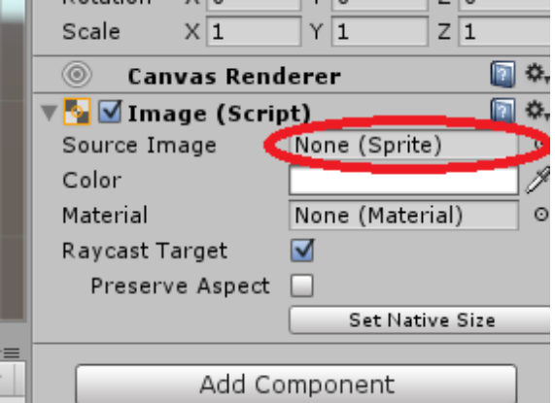
In the inspector for your Image (not the Canvas), you will find a source image field. Put your background here by dragging it into the field or by clicking on the small circle and double-clicking on it in the window that pops up.

If you go to your Game View now it may look okay. However, if you turn on “Maximize on Play” and begin the scene you will see that the canvas doesn't actually necessarily fill the scene. This is because of the “Rect Transform Anchors” of your image. They are represented by the white arrows.
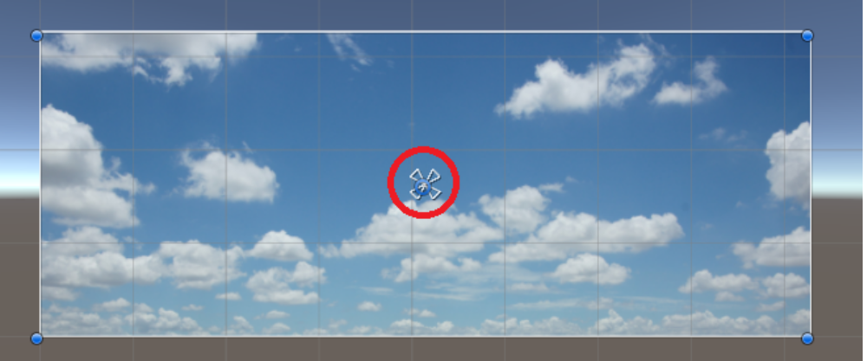
If your image is not anchored to the canvas it will not stretch with it to fit the screen resolution. You can click and drag the arrows so that they are at the corners of the canvas, or you can click the square shown in the image below then click the bottom-right image in the menu that pops up.
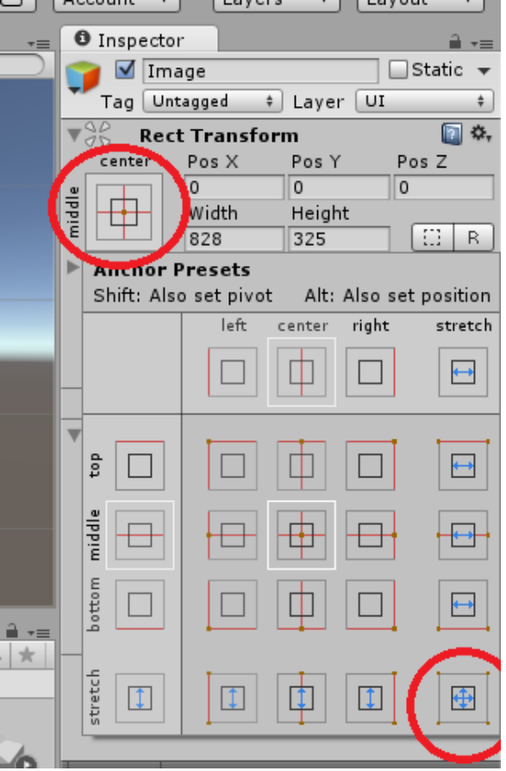
Screen Resolution: The number of pixels displayed on the screen. It is generally quoted as width x height. A popular resolution is 1920 x 1080. Note that resolution is not determined by screen size, therefore a screen can display various resolutions.

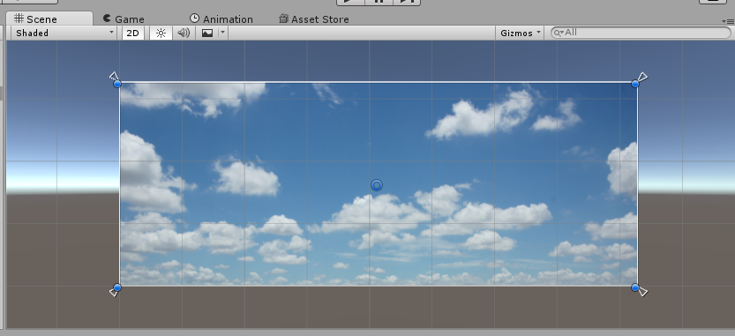
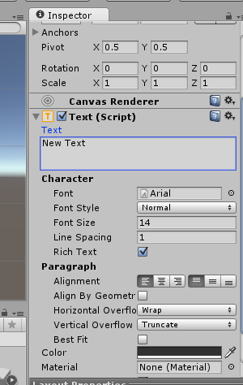
Text and Buttons
Go to “GameObject”, “UI”, and “Text”.

You can edit your text using the inspector. Click the paragraph box under “Text” and write a title for your game.

By default Unity only comes with the Arial font. Try changing the size to something larger. Remember to change the Rect Transform anchors to fit the canvas.

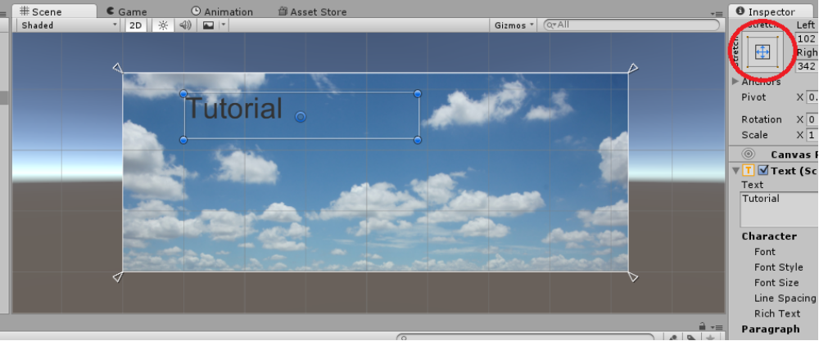

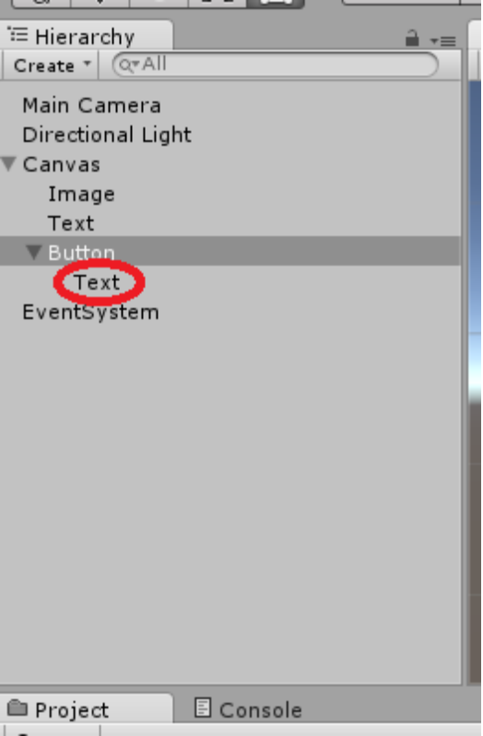
Go to “GameObject”, “UI”, and “Button”. Change the Rect Transform Anchor to fit the canvas. Now, the button should have a text object parented to it. You will have to change this object's anchor too. The button and its text are two different objects.

Change the button's text to “PLAY”.

Try increasing the size of the button then increase the text's font to better fit it.

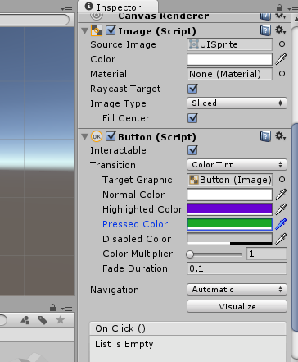
Change the button's “Highlighted Color” and “Pressed Color” in the inspector. These effects will be apparent in the next tutorial.

Notice the bottom section that says “On Click”. It is here that we will put a script that will be activated when the player clicks on the button. We will cover this in the next tutorial.

II – HUD

Save your scene and double-click on your level scene in your Assets to open it.

You should still be in 2D mode. If not, switch to 2D. Now add a Canvas.

Health Bar
Go to “GameObject” and “UI” and add a “RawImage”. Change the colour to black. Again, don't forget to change the anchor to stretch across the canvas. Also make sure that it is parented to the canvas.
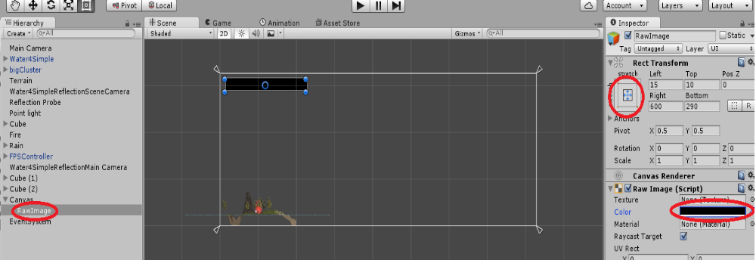
Set the Left Rect Transform to 15, the Top to 10, the Pos Z to 0, the Right to 600, and the Bottom to 290. These specific values are not necessary, but these are the values we will be using in the next tutorial. We are going to have the health bar decrease by changing the Right Rect Transform when the player takes damage.

Now duplicate the RawImage by selecting it and hitting CTRL + D, or by right-clicking it and clicking “Duplicate”. Change this new RawImage's colour to red.

Counters
Finally we are going to set up two on-screen counters: a coin counter and a lives counter.

Add two empty GameObjects to the canvas and name one “livesCounter” and the other “coinCounter”.

You can play your scene to see how everything looks, but you won't be able to see the lives or coin counters yet. These concepts will be continued in the next tutorial.

