I - Introduction

What is Unity?
Game engine: Software for developing video games. Generally comes with various engines within it so that developers do not have to create these engines themselves. Examples of these engines are: the physics engine which emulates real-world physics, and the audio engine which emulates real-world sound waves.

Game platform: Hardware used primarily for playing video games. Xbox One, PS4, Wii U, and 3DS, are all examples of game platforms.

Unity is a cross-platform game engine, meaning it can be used to publish games for various game platforms. It was developed by Unity Technologies and first released June 8th 2005. For this tutorial we will be using version 5.3.4. Please be aware that although many concepts will remain the same, menu placement, scripts, and many other features tend to change slightly with each version. We will also be using a PC with Windows.

What kind of features does Unity include?

As of Unity 5, there are many things that Unity can do one way or another. It is a professional engine that fully meets industry standards. Plus, almost anything that Unity can't already do can be done using custom code.

II - Becoming Familiar With Your Computer
Tower: The main part of a computer set-up which contains the hard drive. Usually includes a disc drive and power button.

Hard Drive: Contains the computer's files and programs. Usually known as the 'C' drive within the computer.

Desktop: Main interface on a computer. Program shortcuts are usually found here, and files can be saved here for quick access.

Taskbar: The bar on the bottom of the screen that allows access to open programs.

Monitor: The computer's screen. You are looking at one right now.

Keyboard: Used in conjunction with the mouse to input commands to the computer.

Mouse: Sometimes in the form of a touch pad, used to control the pointer, which is the arrow used to click on things.

This section is for users who have little or no experience with PCs. If this does not apply to you, you can go ahead and skip to the next section. This section is also primarily for Windows users.

What will you need to know in order to use Unity?
First and foremost, you will need to know how to properly boot up and shut down your computer. Booting up doesn't take much effort besides pressing the power button on your tower, sometimes known as a terminal. Before you get to the desktop you may need to enter a password if you are using a school or workplace computer. Once you are on the desktop, look for the Start Menu on the bottom left corner of the taskbar 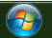. The Mac equivalent to the start menu is the “apple” icon usually found in the top left corner of the screen. In this menu you can click “shut down” or “log off” once you are finished using the computer.

PC controls:
Left Mouse Button (LMB): Mouses generally have three main parts to them: a “left mouse button”, a “right mouse button”, and a “scroll wheel” or “middle mouse button”. The left mouse button is the large portion of the left side of the mouse that can be pressed down. When this tutorial uses the term “click” or “left-click”, it is referring to the left mouse button. “Double click” means to press the button twice in a row.

Right Mouse Button (RMB): The right side of the mouse that can be clicked. This tutorial will sometimes use the term “right-click” to refer to it.

Scroll Wheel (MMB): The scroll will is found in the middle of a mouse. You can turn it forwards or backwards. You can also click it in like a button. This is a “middle mouse click”.

Space Bar: The large, rectangular key on the bottom of a keyboard.

Windows Key: Used to open the start menu. It is the key on the bottom-left with the Windows logo.

Control Key: There are generally two control keys. You can choose which one you are more comfortable using, though some commands require that a specific key is pressed. The Mac equivalent is usually the “command key”. Control can be held to select multiple items at once.

Enter Key: The large key in the middle-right section of the keyboard. The Mac equivalent is the “return key”.

Shift Key: Just like the control keys, there are usually two. Shift can be held to capitalize a letter when typing or to select a row of items (by selecting the first then last item).

Browsing the internet:
Windows and Macs both come with a default internet browser. Windows comes with Internet Explorer and Macs come with Safari. You should be able to find a “shortcut” to open your internet browser either on the desktop or in the start menu. Double click on the icon to open it.

Reaching a website:
File: A piece of information stored on a hard drive. Examples of files include text documents, pictures, music, etc.

Program: A script that can be “executed” (started) on a computer. Most programs must be “installed” in order to use them. Internet Explorer and Unity can both be considered programs.

Internet Browser: A program used to reach different websites on the internet.

Website: A collection of pages on the internet that can be viewed and interacted with.
Websites can be reached either by searching for them in a search bar or by typing in the address exactly in the address bar. Address bars in newer browsers often double as search bars.

Click on the address bar and type in whatever website you are searching for. Then hit the enter key.

III – Installing Unity

Unity website:
Type in “unity3d.com” in the address bar of your internet browser and hit enter.

Click on “Get Unity” once you enter the website.

Under the “Indies & Studios” tab, click on “Free Download” under “Personal Edition”.

Click “Download Installer”.

Depending on your browser's settings, the installation file will either be saved automatically to a certain folder (usually the “Downloads” folder), or you will be given the option to choose where to save it.

Installing Unity:
Once the file is downloaded, find it and double click on it to open it. If it is saved in your “Downloads” folder, open the start menu and click on “Documents” on the right side of the menu. In the window that opens up, click “Downloads” in the top-left area. Find the file “UnityDownloadAssistant-5.3.4f1.exe” in this folder and double click it.

If a User Account Control window pops up, click “Yes”.

Click “Next” to begin the installation.
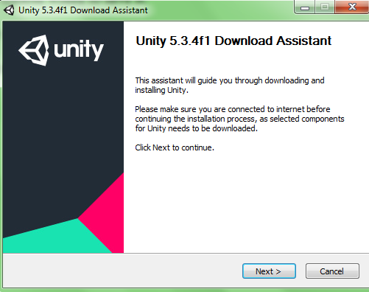

Accept the terms of the License Agreement then click “Next”.

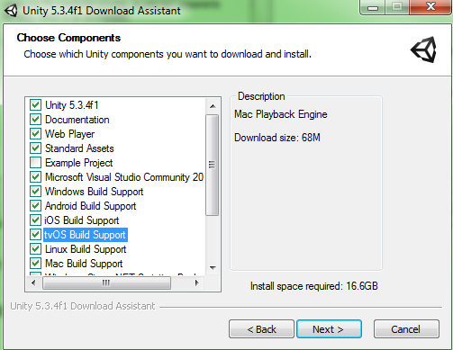
Make sure the appropriate boxes are checked, then click “Next”. The “Build Support” boxes are not all necessary, except for Windows Build Support. Any “Build Support” boxes checked will allow you to build games that can be played back on that platform. If you are only planning on using Windows then other build supports are not necessary.
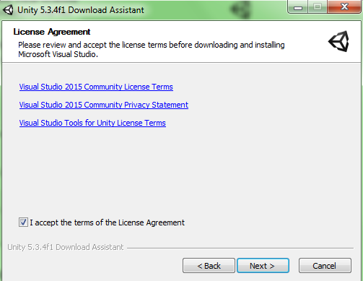
These settings are fine. Click “Next”.

Accept the License Agreement and click “Next”.

Allow the installation to finish. This may take several minutes to an hour to complete.

Note: Visual Studio may open during the installation and say that it is “creating a system restore point”. It may hang here and stop progress on the installation. If this happens, right-click on the taskbar and open the Task Manager. Go to the “Processes” tab and click “vs_community.exe” to highlight it. Then click “End Process”. If there are two then end both. An error message will pop up. Click “Ignore” to continue the installation.

Once the installation finishes you can check “Launch Unity” and click “Finish”.
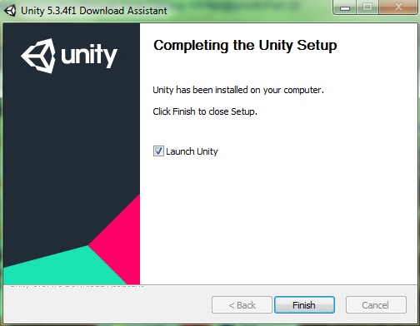

There should be a shortcut on your desktop that you can double click on from now on to open Unity. If not, you can find it in the start menu under “All Programs”.

Unity will ask that you set up an account. You can click “Work Offline” for now if you don't want to make an account. Unity accounts can be used to browse the “Asset Store” and download assets, which we will explore in a later tutorial.

