I – Standard Controllers

Right-click in your Assets window, hover over “Import Package”, and click on “Characters”.
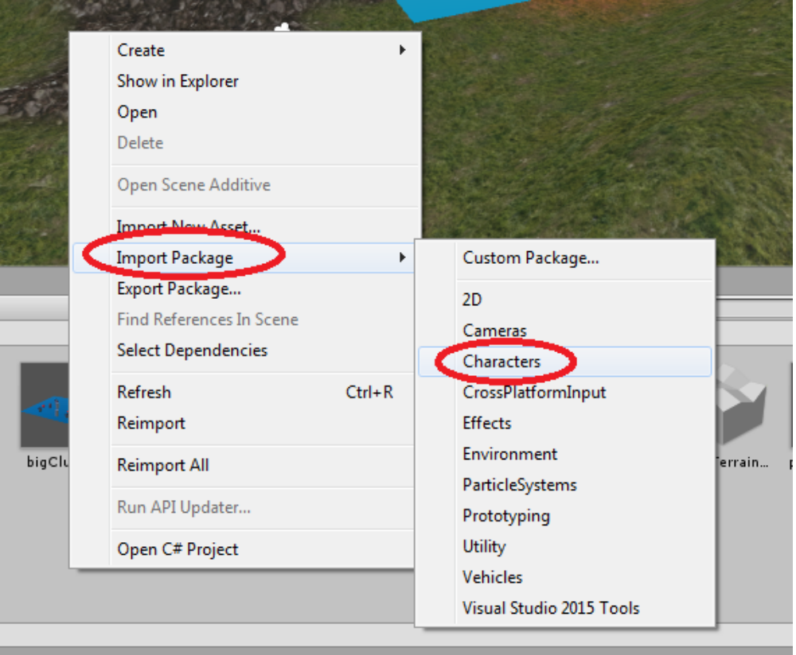
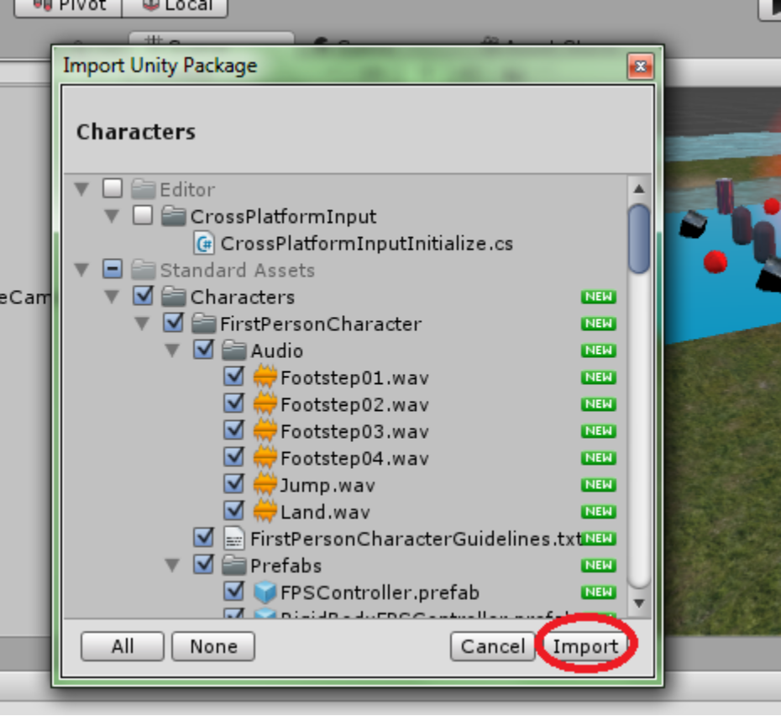
Same as importing the Environment package, this window will allow you to select which assets you wish to import. Simply click “Import” this time.

Double-click on the “Standard Assets” folder then go into “Characters”.
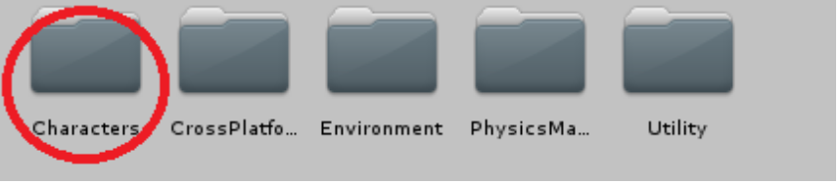
There are two standard controllers that we will be using, a first-person and third-person. Enter the “FirstPersonCharacter” folder, then enter “Prefabs”.

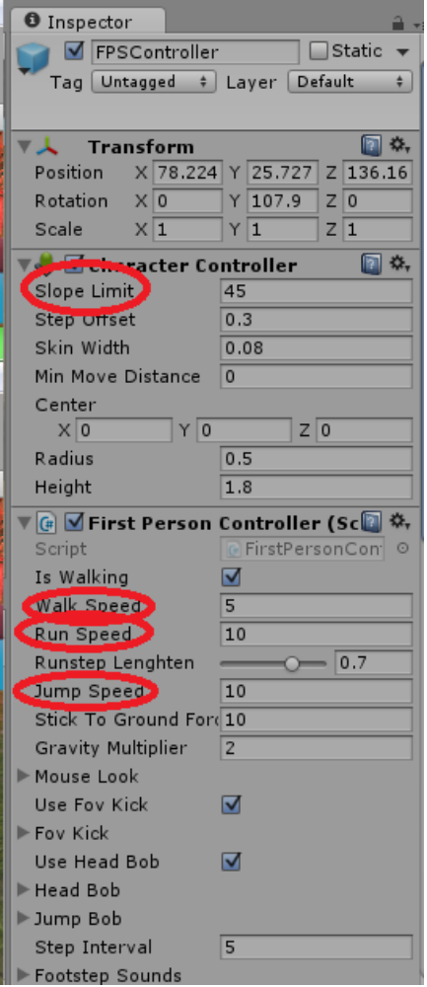
There are two prefabs here: “FPSController.prefab” and “RigidBodyFPSController.prefab”. You may recall that we added “Rigidbody” to the inspector for a cube in the last tutorial. Unity's “Rigidbody” feature allows objects to be acted upon by Unity's physics engine. For example, the cube from the previous tutorial will now be acted upon by gravity. If you were to place this cube above the ground without a Rigidbody it would remain in the air when you start the scene. With the Rigidbody it will fall to the ground when the scene begins.

That being said, having a Rigidbody character controller can result in unwanted results. For example, colliding with an object can cause unwanted rotations or movement in the controller. Because of this they are better suited for vehicles. So, drag FPSController.prefab into your hierarchy or scene view and place it somewhere over the terrain.

Take a look at the inspector. There are a number of adjustments you may want to make. The Slope Limit describes the highest incline that the controller can move up. Still, with the standard controller it is possible to climb any slope by repeatedly jumping up it. Walk and run speed are self-explanatory, while Jump Speed really describes the height that the player can jump.

Controls
Use the W key to move forward, S to move backwards, A to strafe left, D to strafe right, the space bar to jump, and hold SHIFT to run. You can also move the mouse to look around.

Press the play button at the top to begin. If you click on “Maximize on Play” first then you can play in fullscreen mode. Press the ESC key during play to bring the pointer back. You can then click on the play button again to stop.
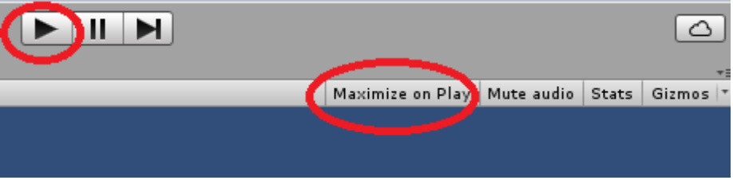

Try holding SHIFT and running into the Rigidbody cube.

You can also try adding the Third Person Controller and playing with that using similar controls.

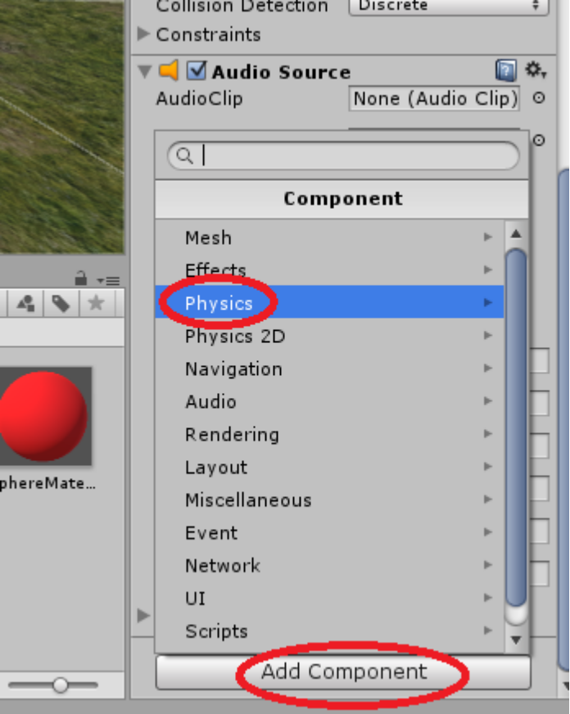
II – Components

Colliders

Scroll to the bottom of your FPS Controller's inspector and click “Add Component”, then click “Physics”.

Now click “Box Collider”.

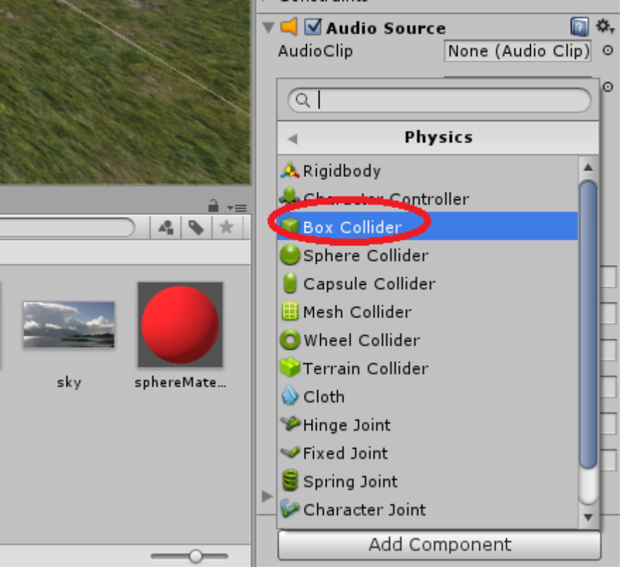

A collider is what game engines use to decide when one object is touching another. Notice the new green box around your controller.

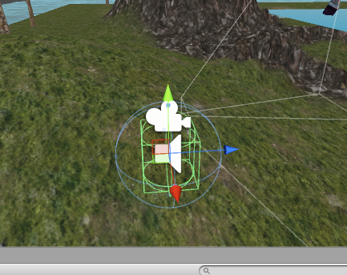
Recall when you changed the parameter of the reflection probe. We are now going to do the same with this collider.

Under the Box Collider component in your controller's inspector, click “Edit Collider”.
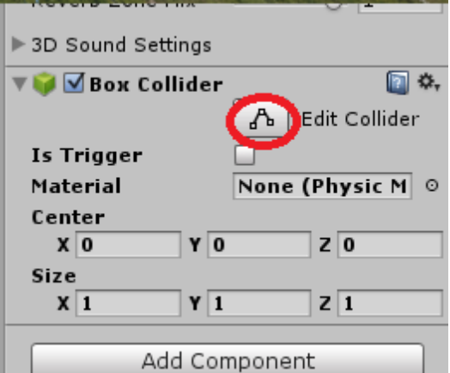

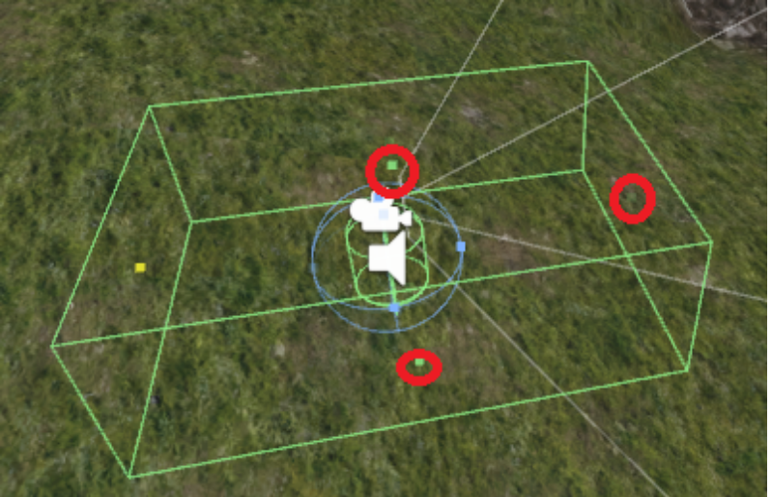

Now click and drag the small squares to resize the box. Once you are done try playing your scene again and push the box around. Notice that you don't have to get so close to it anymore.

Physic Materials

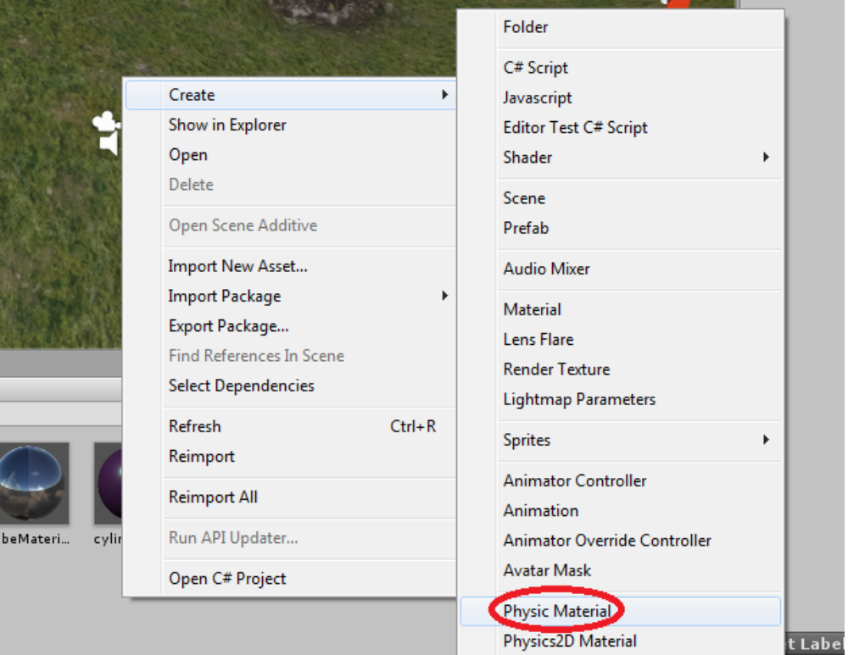
Right-click in Assets, hover over “Create” and click “Physic Material”.

A physic material is similar to a regular material, except instead of changing the looks of an object it changes how it interacts with Unity's physics.

“Dynamic Friction” and “Static Friction” determine how easily the affected object can be moved both while it is in motion (dynamic) and while it is at rest (static).

Try changing both frictions to 0.1. Now click on the small circle next to “Material” under the Box Collider component of your Rigidbody Cube. Find your material and double click it to apply it. Now do the same to the Terrain Collider on the terrain.

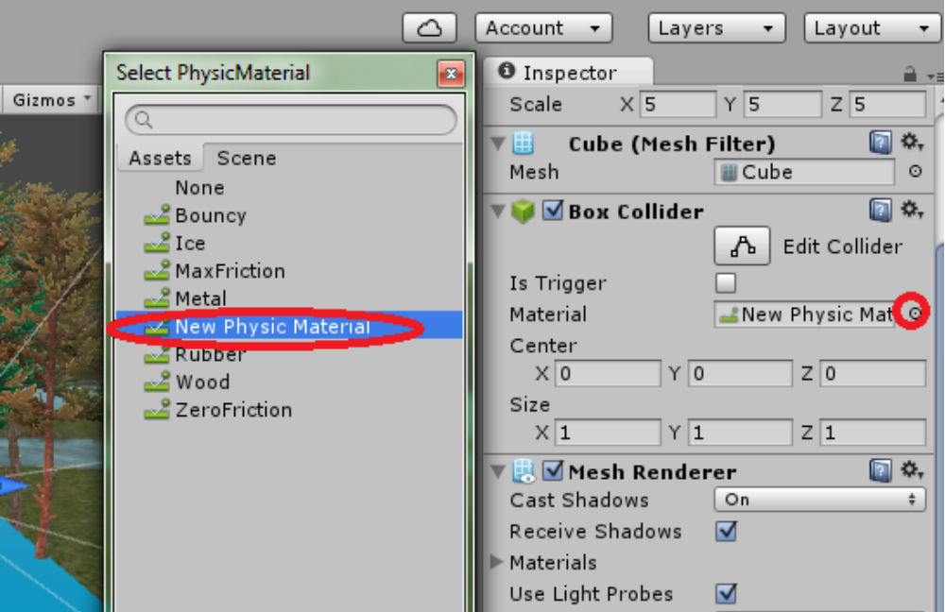
Try pushing the cube around the terrain.

III – Animations

Joints
We are going to create a pendulum using Unity's physics engine.

First create a cube and four spheres. Stack them on top of one another with the cube on top and without them touching the ground, as shown below.
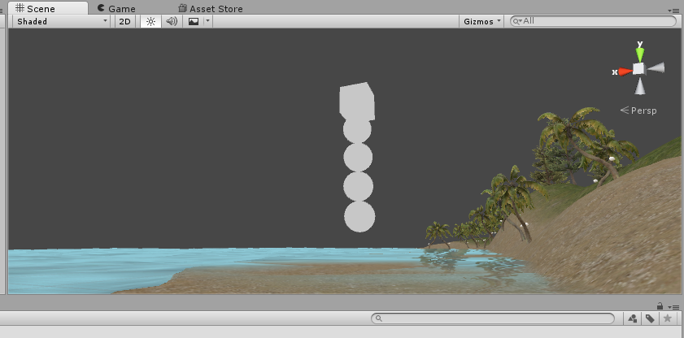
Now parent the spheres to the cube.
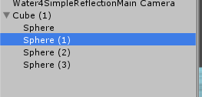
Add the Rigidbody component to the cube and the four spheres.
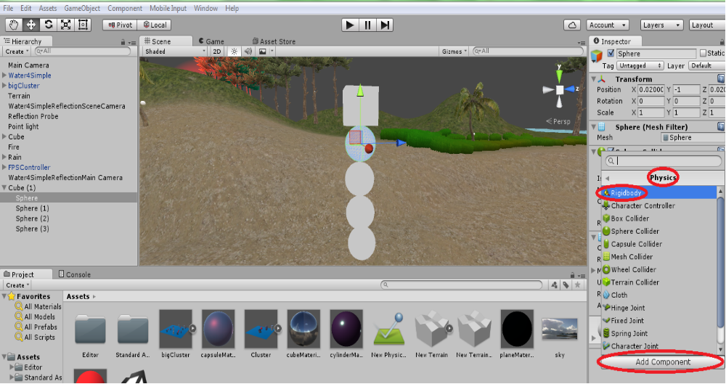
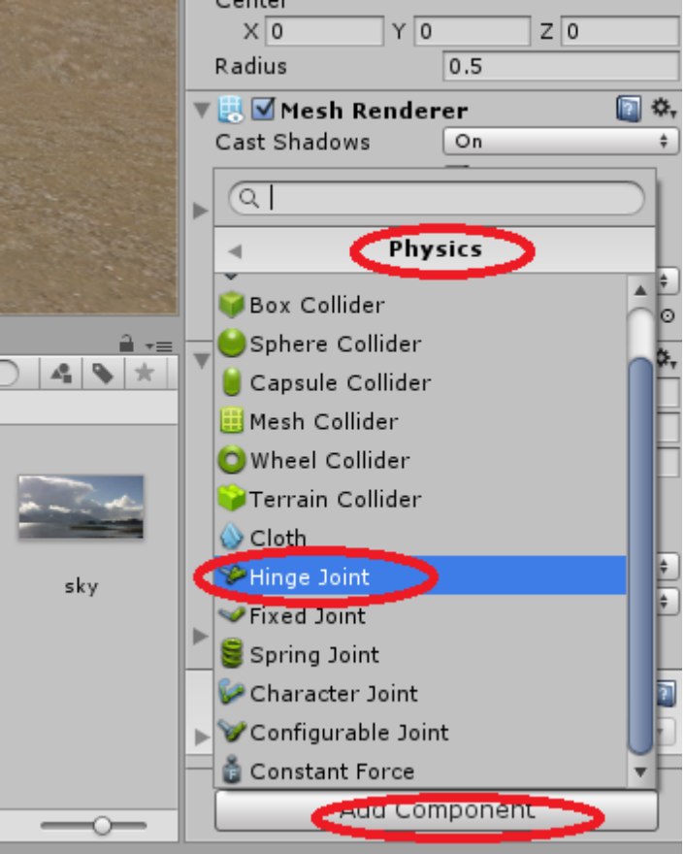
Add a Hinge Joint component to each sphere.

Each Hinge Joint has a “Connected Body” field. For each object you must add the object that it is connected to here. For example, the highest sphere is connected to the cube. Highlight your first sphere and click and drag the cube into the field that says “None” or click on the small circle and select the cube. For the second sphere, do the same but add the first sphere to this field and so on.
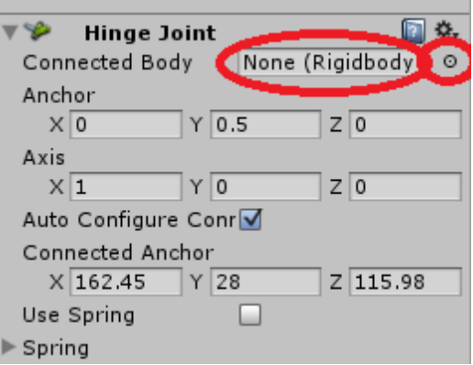

Notice the “Anchor” field. This is where the two objects are technically connected. Now notice the small orange arrow above each sphere. This is the anchor and its direction. The hinge will swing in the direction that the arrow is pointing. You can change the direction by changing the “Axis” field. Change the X axis field to -90 for each joint.

In order for the pendulum to work we need to set it up at its point of highest potential energy. Move your spheres so that they are in a straight horizontal line like the image below.
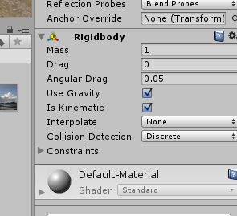
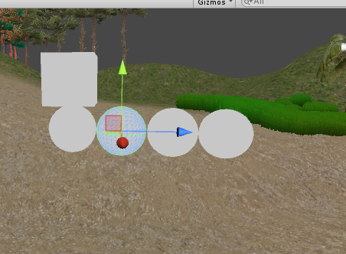
Now you will need to change the anchors. The first sphere should be fine because you didn't move it. Notice the location of your orange arrows. They need to be moved to the centre-left of their respective sphere. Change the “Anchor” fields to do this. (0, 0, -0.5) should be sufficient for each sphere.

Check off “Is Kinematic” for the cube to keep it in the air.

Start your scene to see it in motion.

Animators
Now we are going to make a similar pendulum using an animator.

Make a cube and four spheres and set them up as before.
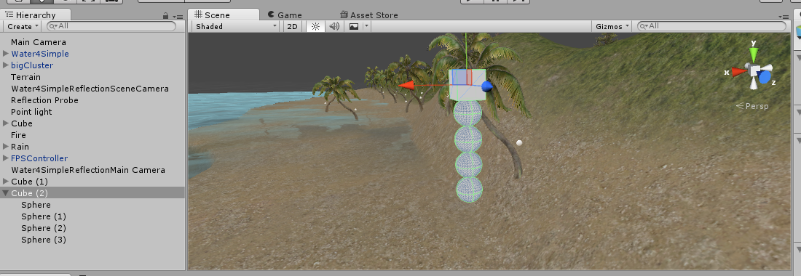

Now we need to open the “Animation” window. Go into “Window” and click “Animation”. It will open up in a separate window. Click and drag the tab that says “Animation” next to the Game View tab to move it into your main window.

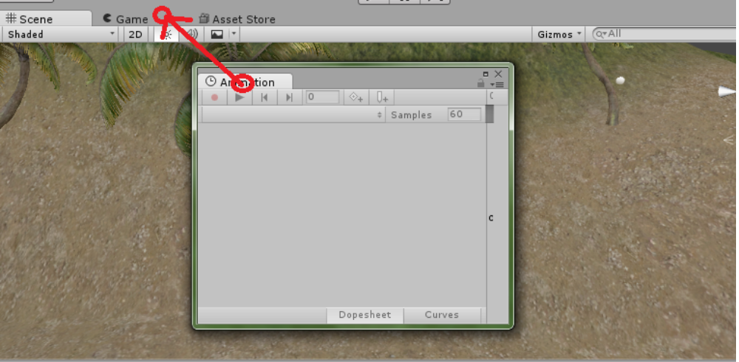

Select your cube and click “Create”.
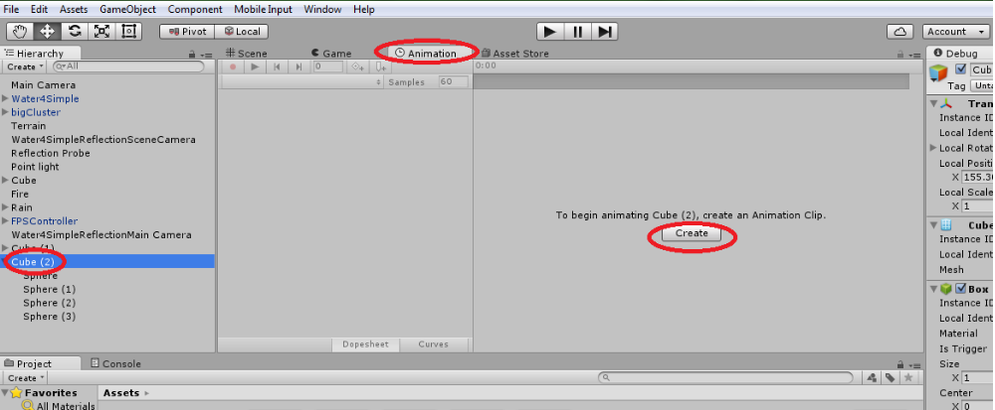
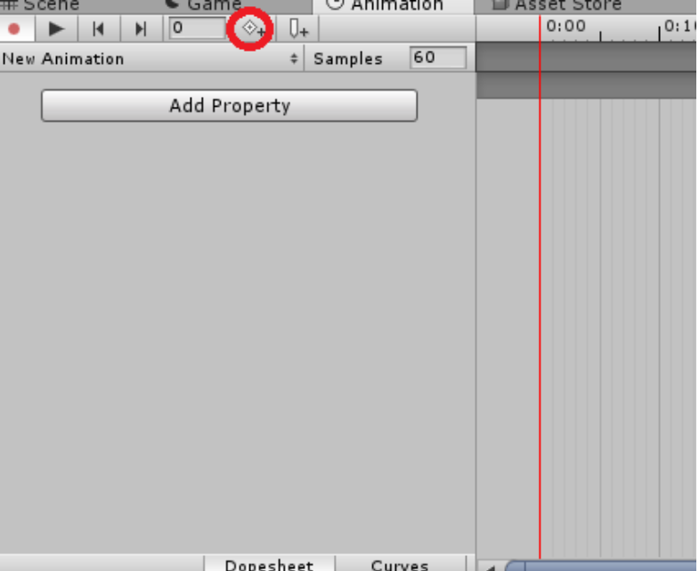Keyframe: An important frame in an animation. A bouncing ball typically has 3 basic keyframes: the highest point, the point where it first contacts the ground, and the squash where it is at its lowest point.
Save it into your Assets folder. An animator will automatically be created in your Assets and be added to your cube as a component.

In the Animation window you will see a timeline. Start by adding a keyframe by clicking the diamond button.

Our animation will have a total of 5 keyframes. The first will be the pendulum as it is now. The second will be the pendulum at its
highest point. The third will be at its
lowest point again. The fourth will be
at its highest point on the right. The
fifth will be back to the starting
position again.

Click the “2” position on the timeline
to move the cursor there or change
the number “0” to “2” as shown
below. Go over to your scene view
and move your pendulum to its
highest point on the left side.

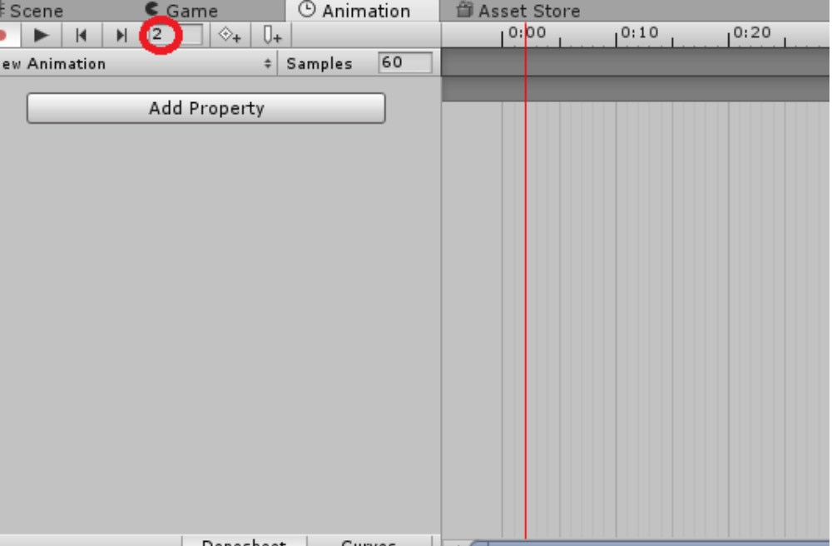
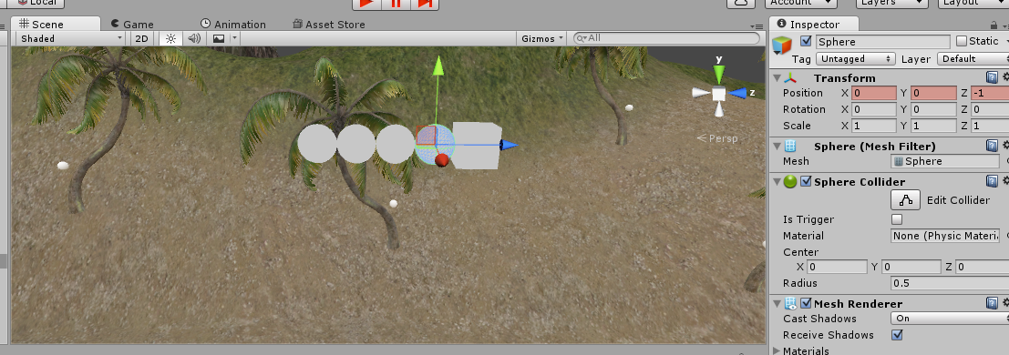
You can quickly move the spheres by changing their Positions under “Transform” to (0, 0, -1), (0, 0, -2), (0, 0, -3), and (0, 0, -4).

Unity should actually be making keyframes by itself. You can tell that a position on the timeline is a keyframe by the diamond shape.

Change the time to “4” and move the spheres back to their starting positions. Then change it to “6” and move them all the way over to the right side. Finally, change it to “8” and move them back to the starting position.
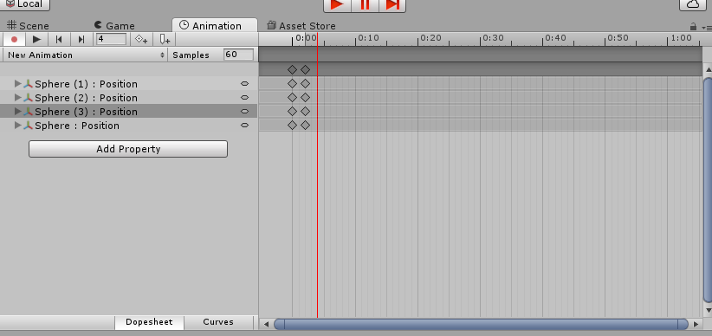
Now you can play your scene and see your animation in action.

